Where’s ~~Waldo~~ Wildfire

Explorations with TensorFlow Image Classification

─

**Deep Learning COMP4531 Spring 2024**  
Brittany Laurent, Travis Mark, Kai Mazurczyk

# Abstract

The team explored the limitations, challenges and capabilities of convolutional neural networks (CNN) by working through an image classification problem.

We began by testing various machine learning and deep learning methods on a *Where’s Waldo* dataset of illustrations. An extremely small number of samples for Waldo images tested the learning capacity and limits of even the most capable neural nets (ie ResNet). After applying a variety of data cleansing and augmentation techniques and a range of reference models, the team was forced to abandon the dataset. The lack of readily available data hindered our reference model’s ability to learn and generalize this challenging problem. However, we worked out clear requirements and framework for an image classification problem.

The team repeated the process and developed a custom convolutional neural network that identified the presence of fire in an image, using a wildfire dataset. With balanced, complete data and very clear differences in the two classes, the team iteratively built a simple and efficient CNN that performed with a high level of accuracy.

# 

# Disclaimer

The images used in this research paper are the property of their respective copyright holders. They have been utilized solely for personal and educational purposes within the context of this research. The use of these images and materials is in accordance with the principles of fair use for academic and research purposes. No copyright infringement is intended.

# Table of Contents

**Part One: Where’s Waldo**

Problem Statement

Explain the problem set up/dataset

Data Exploration

Problem Set Up: Reference Models

Alternative Approaches

Convolutional Neural Nets

Next Steps

**Part Two: Where’s Wildfire?**

Problem Statement

Explain the problem set up/dataset

Data Exploration

Problem Set Up: Reference Models

Gradient Boosted Trees

ResNet

Neural Network Implementation & Refinement

Basic CNN Model

Three Layer CNN

Adding Neurons, Padding and Drop Out

Adding Convolutional Blocks

Six Layer CNN

A Winning Model

Summary of Tuning

Conclusions

Evaluation of the Final Model

Error Investigation and Next Steps

**References**

# 

# Part One: Where’s Waldo

## Problem Statement

*Where’s Waldo* is a series of children’s puzzle books filled with complex illustrations that are designed to keep readers engrossed with one task - finding the main character Waldo. Wearing a red and white striped shirt, knit hat and round glasses, Waldo is tucked into varying scenes amidst crowds of other characters and repeated patterns, with different size and placement in each image.

The required tasks to solve a Where’s Waldo puzzle are well suited to a deep learning challenge:

1. **Image Classification**

A model must distinguish Waldo’s features from similar characters and distracting patterns in the rest of the image. Therefore a model should accurately identify “Waldo” and “not Waldo” from the image provided.

1. **Localization**

Once Waldo is identified, the character’s location in the illustration must be specified. The model must return boundaries and placement of the Waldo region of the image.

1. **Object Detection**

The output of steps 1 and 2 make up the essential information for object detection, and they are tasks that are difficult to separate.

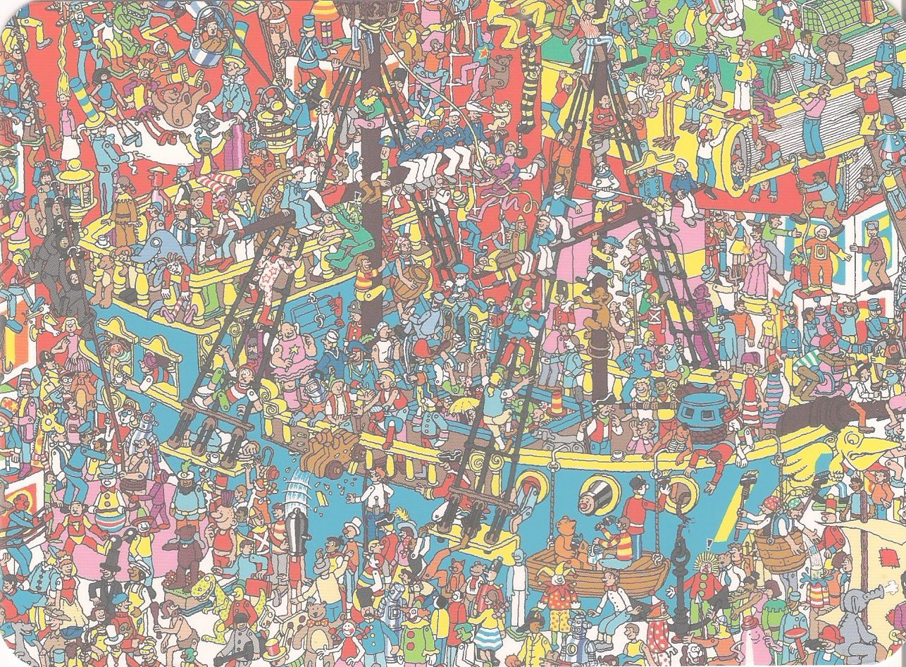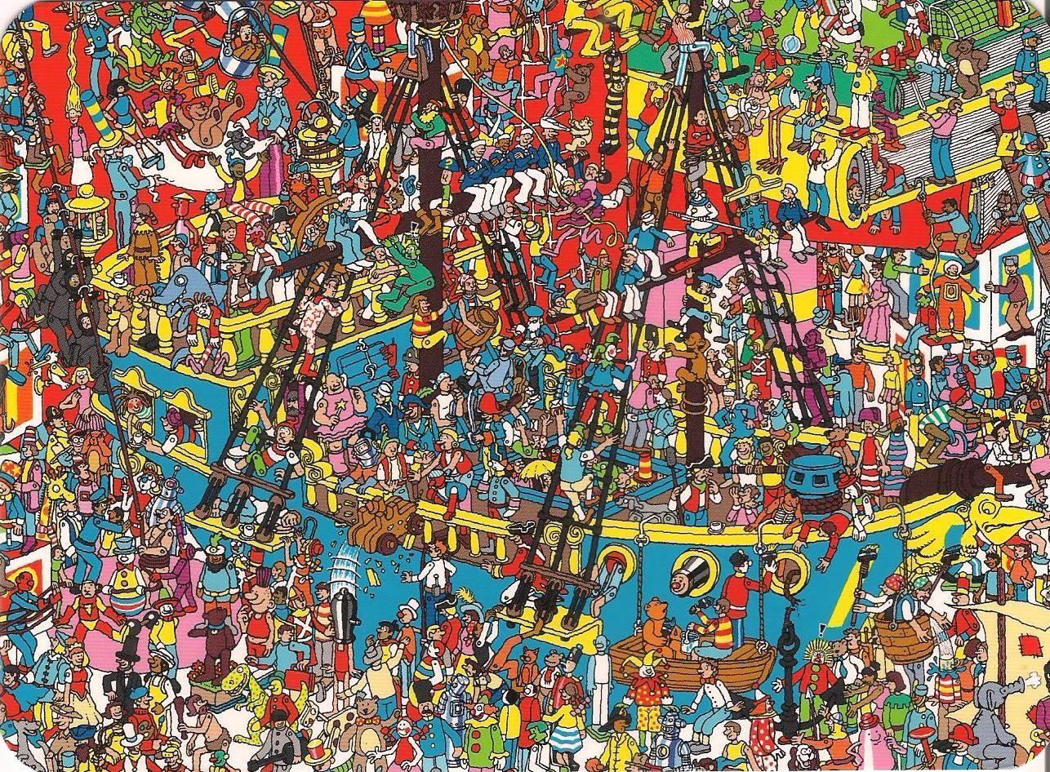

There are machine learning methods for classification that could label Waldo images, and clustering methods that might be able to specify probable placements for Waldo in each illustration. However convolutional neural network (CNN) models have led the way in computer vision due to their sophisticated ability to combine high and low level features and efficiently compute a high number of parameters for refined object detection.

We seek to develop a simple model that not only accurately and efficiently detects Waldo, but performs reasonably well against leading CNN models with greater efficiency and simplicity.

## Explain the problem set up/dataset

Inputs

**Image Data**

We selected a dataset of Waldo illustrations from Kaggle, comprising 5,376 RGB images from 19 scanned pages of the *Where’s Waldo* books. Each image is a 64px square slice collected gridwise from the page. The images are converted to numeric arrays of RGB pixel values range(0,255).



**Image samples from the Waldo class**

**Class Labels**

Waldo’s presence in an image is a binary classification - Waldo is either there or not. The files are labeled either ‘Waldo’ or ‘NotWaldo’ in their source directory, and encoded as integers during preprocessing.

**Annotations**

This dataset is not annotated with coordinates for bounding boxes around the Waldo subregions. This information is essential to train object detection models on localization. We are experimenting with methods to auto annotate our training data.

One method that we have found that works is providing the coordinates of the bounding box to the model, and train it to predict the coordinates of the bounding box. Ideally, the fully trained model will predict a bounding box that overlaps the actual bounding box. We are doing this using multiple convolutional layers, each followed by batch normalization and max pooling.

A regression block was defined to contain the output for the box location. We flattened the output from the convolutional block and then use dense layers and then a final layer with no activation.

A classification block was defined to have a flattened layer, followed by dense layers and a final dense layer with a single neuron and a sigmoid activation. The sigmoid activation is for binary classification.

We synthesized data, created bounding boxes and implemented a convolutional neural network to classify and localize Waldo.

Outputs

An effective object detection model should provide both classification and location of an image.

**Classification**

We expect the model to return a probability that Waldo is in the image, that can be used to infer a prediction.

**Location**

We expect the model to indicate where Waldo is in the image. This is accomplished through bounding box regression where a box is fit around the region of interest, fitting the edges to minimize MSE against the boxes given during training. These can be returned as coordinate values (below we assume a YOLO format) or visualized with Keras CV as a box on top of the image, indicating the region of interest.

|  | **Data Type** | **Training Min** | **Training Max** | **Training Mean** | **Encoding** |
| --- | --- | --- | --- | --- | --- |
| **Training Inputs** | | | | | |
| JPG | 64x64 float pixel values, three channel RGB | [0,0,0] (scaled) | [1,1,1] (scaled) | [0.63, 0.59, 0.49] (scaled) | 64 x 64 x 3 array |
| Classification | Binomial categorical | 0 | 1 | 0.01 | 0 = not Waldo  1 = Waldo |
| Location | array | n/a | n/a | n/a | [x, y, w, h] normalized relative to the larger image |
| **Output Variable** | | | | | |
| Classification | Probability float |  |  |  | 0 = not Waldo  1 = Waldo |
| Location | array |  |  |  | [x, y, w, h] normalized relative to the larger image |

Indicative ranges for the training set are min-max scaled from 256px and based on a random state of size n = 3764.

## Data Exploration

**Distribution of Image Data**

We explored the RGB channel distributions for any qualities in the images that would otherwise bias a Waldo or non-Waldo class. The Waldo and non-Waldo images had nearly identical channel distributions.

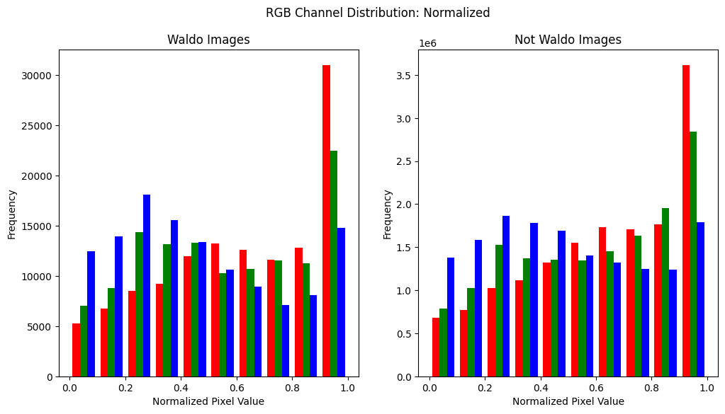

Training set: min-max scaled image data, n = 3764.

**Frequency of the Waldo Class**

Of the 5,376 images in the dataset, there are only 39 labeled Waldo images, making our main class size less than 1% of the dataset. The dataset creator recognized this problem and already extended the class by including images with Waldo-like characters under this label.

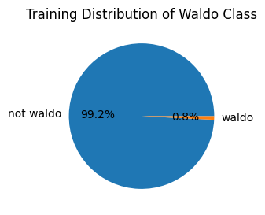

Training Set: Not Waldo n = 3,374, Waldo n = 30

This imbalance is inherent to the challenge we are trying to solve – Waldo is a small detail in a larger and intricate illustration.

To address the imbalance of the images containing Waldo, we:

* Increased the slice size from 64px to 128px for both classes, taking larger snapshots from the original illustration. This decreased the overall number of samples, but using a larger image area increased the likelihood of Waldo placement somewhere in the image, and slightly increased the size of the Waldo class.

 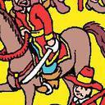

Increasing the slice size from the original image - 64px to 128px square

* Produced additional images using image augmentation techniques like flipping and rotation. Implementing a method to flip the image and rotate it at 90, 180, and 270 degrees provided us with 5 times as many Waldo images for our model.

**Original Image Flipped 90 Degree Rotation**

**  **Together these changes increased the size of the Waldo class to 13% of the training data.

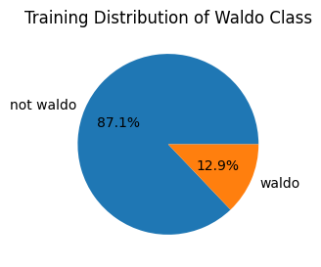

Augmented Training Set: Not Waldo n = 1061, Waldo n = 157

## 

## Problem Set Up: Reference Models

### Alternative Approaches

Before committing to more complex solutions using Neural Network, we explored other machine learning models, including KMeans, K-Nearest Neighbors, and Gradient Boosted Trees.

The full size Where’s Waldo images are broken down into smaller images arranged in a grid to cover the full image. These smaller images are named according to their position on the grid. Using this naming convention as x-y coordinates, we plot the location of Waldo in the images.

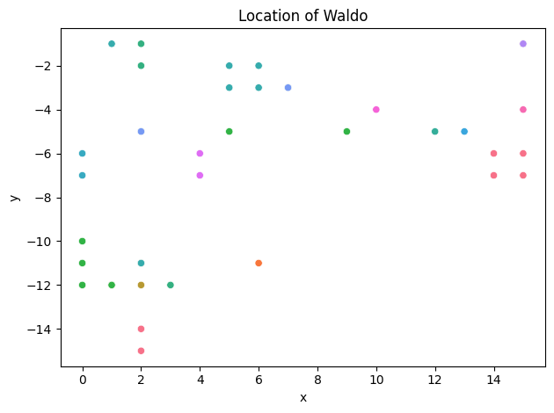

**KMeans**

Using these x-y coordinates, we implemented a KMeans algorithm to create 2 clusters, with the objective to classify Waldo and non-Waldo images in a test set. This approach yielded a precision of 0.01 and an F1-Score of 0.02. This approach was ineffective because the algorithm merely separated the data across the horizontal. This essentially labeled all images in the bottom half as Waldo and not the top half as non-Waldo, which created over 99% false positives.

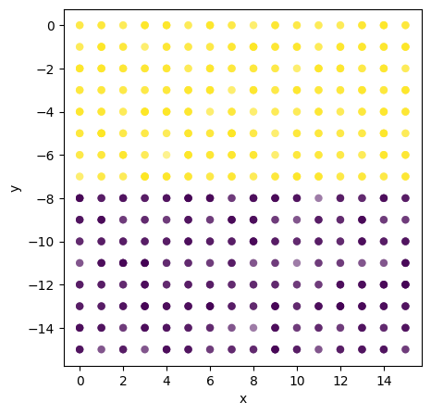

**K-Nearest Neighbors**

With the known true labels and the x-y coordinates, we utilized a similar approach with K-Nearest Neighbors to predict which images in the test set contained Waldo. The test set contains 1,613 images, 12 of which contain Waldo. The K-Nearest Neighbors algorithm was not able to correctly identify any of these 12 Waldo images. However, it did significantly reduce the number of false positives down to 8 images. The K-Nearest Neighbor algorithm was ineffective in classifying the Waldo images.

**Gradient Boosted Trees**

In another approach, we utilized the gray scale images and flattened them into an array. We implemented Gradient Boosted Trees with these pixel values to attempt to classify the Waldo images. This test data set again contained 1,613 images, of which 10 contained Waldo. The Gradient Boosted model correctly identified 1 of the 10 images. However, the model predictions contained no false positives. Thus, the precision of the model was 1.0, but the recall was only 0.1. The F1-Score of this model was 0.18. The Gradient Boosted Trees model was also ineffective in detecting the Waldo images.

### Convolutional Neural Nets

As mentioned above, convolutional neural network (CNN) designs currently lead the industry in image classification and object detection tasks. First, we implemented a rudimentary CNN to evaluate the viability of the network. Then, we explored Resnet as a famously accurate but also maximally complex model, so we would have a high benchmark for our own model.

**Basic CNN**

We employed a simple implementation of CNN to determine if CNN was a potentially viable solution. The architecture of this CNN was 2 convolutional layers followed by a max pooling layer, then a third convolutional layer with another pooling layer and finally a fully connected layer. ReLu was used as the activation function in deep layers and sigmoid in the output layer. In this base implementation we did not employ any padding in the convolutional layers or dropout or regularization in the dense layer. An 80/20 train validation split was used on the data.

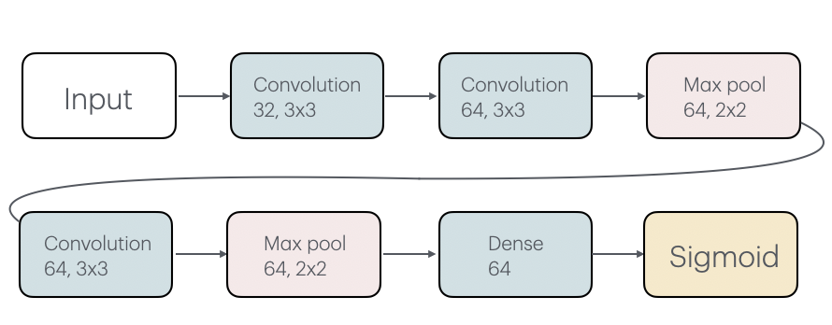

The basic CNN was able to achieve 100% recall and precision on the training data in about 60 epochs. However, the model is horribly overfit and was unable to achieve any positive results on the validation data. On the validation set, the model was not able to correctly identify any of the Waldo images.

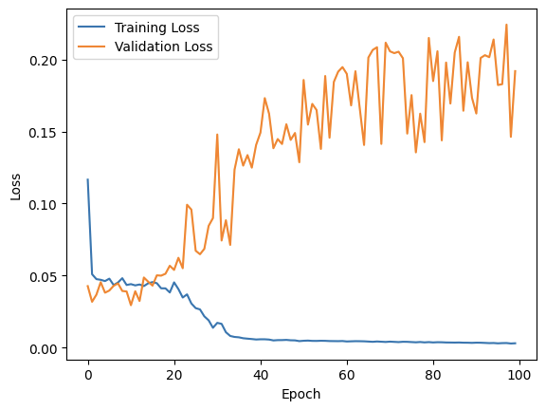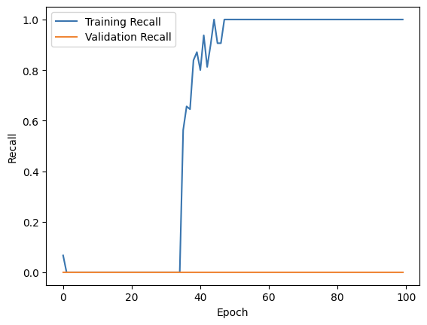

This led the team to conclude that while CNN is a viable method, a simple solution was not successful and a more complex architecture would be necessary to achieve our goal. This also provided us with other critical information regarding the model architecture. First, we identified the need for dropout or regularization in the model to prevent overfitting. Second, while proving the model was able to learn from the images in the training set, the poor performance on the validation images led us to consider the need for more Waldo image data to better learn from and produce a more effective model on unseen data. This discovery led the team to discuss ways to address the imbalance in our classes and to increase the number of Waldo images using data augmentation.

**ResNet**

ResNet is famous for advancing the accuracy and capacity of neural networks through its innovation of a residual learning framework. ResNet introduced ‘short cut connections’ between every few layers, applying an identity to the activation function to preserve data through layer depths of 50, 100 or more. This innovation enables deeper and more complex architectures, so models can train to a higher level of accuracy without encountering vanishing or exploding gradients during backpropagation.

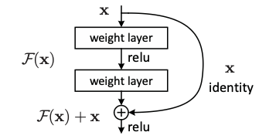

He et al. (2015) *Deep Residual Learning for Image Recognition*

**Transfer Learning & Training**

We tested a Keras implementation of ResNet50 on our Waldo problem. This model was originally trained on ImageNet, and therefore required transfer learning to our application.

We trained the top average pooling and classifying layers up to 100 epochs and 0.0001 learning rate. Due to our imbalanced classes, our model reached high levels of accuracy and precision very quickly. However it slowly struggled to increase recall with each step, and the longer we trained it became apparent we were getting underwhelming results, while the model was growing overfit. The model reached a recall of 0.97 at the 100th epoch, but validation recall never broke past 0.41, hovering in this range from the 50th epoch forward.

**Augmented training dataset 128px  
100 epochs, step size = 0.0001**

## 

## Next Steps

We trialed a range of models ranging from very simple to complex. However even the most capable CNNs did not achieve the high level of performance we expected.

Accuracy and precision were reached very early, and the training/validation deltas were in very close range for these metrics. Only recall, our most important metric, continued to struggle. This led us to conclude that even after data augmentation, we still had challenges with our data and imbalanced class sizes, which must be addressed before continuing. We would need to source or create more Waldo images in order to balance the classes. Before investing in this effort, we decided to find a similar image classification problem, with aerial or landscape images and noisy backgrounds, to determine if a CNN was a viable solution to the Where’s Waldo problem, given enough data.

## 

# Part Two: Where’s Wildfire?

## Problem Statement

Learning from our models’ challenges with the *Where’s Waldo* dataset, we identified a collection of outdoor imagery labeled for the detection of wildfires. This proved an interesting application of image classification with potential benefits for environmental and public safety.

The wildfire dataset also was far more balanced with two equally sized classes, which provides sufficient information for our candidate model to learn.

The underlying nature of our problem did not change greatly from the Waldo dataset. Instead of applying image classification to locate a character in an illustration, we aimed to develop a model that could accurately distinguish the visual qualities of fire from a range of outdoor environments and conditions.

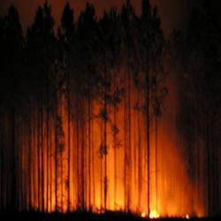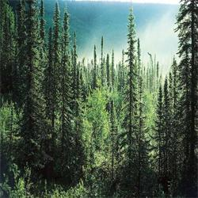

Samples from the fire and not fire classes

## Explain the problem set up/dataset

Inputs

**Image Data**

We selected a dataset from Kaggle, comprising 1,900 RGB images from various outdoor landscapes. Half of the photos showed wildfires in different environments and varying in the fire’s size and severity. Each 250px square image was converted to numeric arrays of RGB pixel values range(0,255).

**Class Labels**

As with the Waldo problem, we treated fire images as a binary classification - either there is fire in the image or not. (Measuring the size and extent of the fire were not considered in scope for the problem.) The images were labeled either ‘fire’ or ‘notfire’ in their source directory, and these labels were encoded as integers during preprocessing.

Outputs

As a binary classification problem, we expected the model to return a probability that there is fire in the image, that can be used to infer a prediction.

|  | **Data Type** | **Training Min** | **Training Max** | **Training Mean** | **Encoding** |
| --- | --- | --- | --- | --- | --- |
| **Training Inputs** | | | | | |
| JPG | 250x250 float pixel values, three channel RGB | [0,0,0] (scaled) | [1,1,1] (scaled) | [0.42, 0.36, 0.29] (scaled) | 250 x 250 x 3 array |
| Classification | Binomial categorical | 0 | 1 | 0.51 | 0 = not fire  1 = fire |
| **Output Variable** | | | | | |
| Classification | Probability float |  |  |  | 0 = not fire  1 = fire |

Indicative ranges for a training set of n = 1500 sampled from a random state. Values reflect min-max scaling from 250px.

## Data Exploration

Frequency of the Wildfire Class

Because imbalanced classes were our main challenge with the Waldo dataset, we first reviewed the distribution of Fire and No Fire classes in the training data. The classes were evenly split with 51% of data in the Fire class across 1,500 samples. This gave us confidence that there was sufficient data in each class for deep learning.

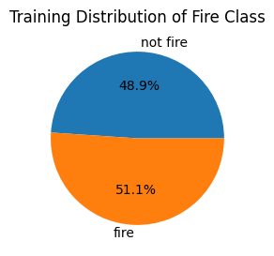

Training Set: Not Fire n = 734, Fire = 766

Distribution of Image Data

We explored the RGB channel distributions for any image qualities that would indicate the Fire and No Fire classes. Clear differences in color range across the two classes highlighted what the model may prioritize during learning.

**RGB Channel Histogram**

A histogram of the RGB channels showed the range of color values used in each class. Fire images had higher values of red and lower values for blue and green when compared to the No Fire images.

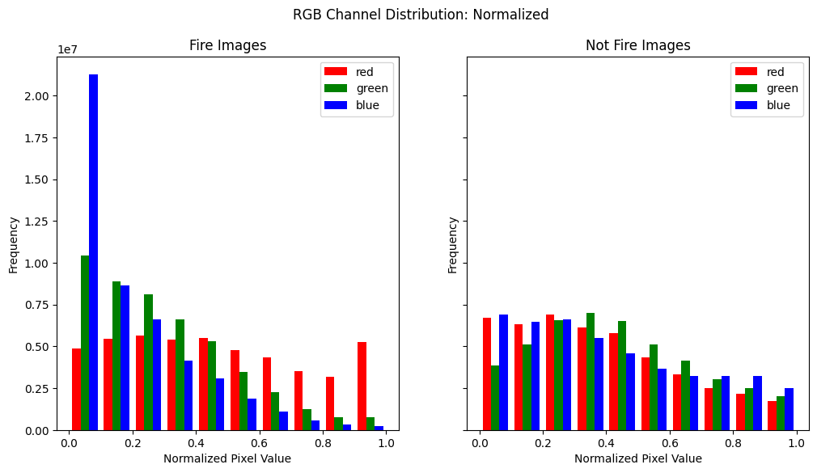

Training set: min-max scaled image data, n = 1500.

**Mean Pixel Value & Color Placement in Images**

We were also interested in any class differences in where colors appeared in each image. We plotted the mean RGB value for each pixel on a heat map.

The Fire class had the highest red and green values near the bottom of the image. Intuitively, this makes sense because this is where we'd expect fire to usually be, flowing from an object on the ground. The blue channel is also far lower compared to the No Fire class, which in general showed more color toward the top of the image.

## 

Training set: min-max scaled image data, n = 1500.

This provided insight to possible features the model may emphasize during learning, as well as possible points of failure.

* If Fire images are more red, how might the model classify red images that do not contain fire, such as a sunset?
* If the Fire images have less blue, how might the model classify a fire on a bright, sunny blue day, such as an image of a fire pit safely burning at a campsite?

## Problem Set Up: Reference Models

As before with the Waldo dataset, we trained a Gradient Boosted Tree and ResNet CNN as reference models to infer the most effective techniques and baseline scoring that should be considered for our final model.

### Gradient Boosted Trees

Following the same steps outlined for the Waldo dataset in Part One, we implemented Gradient Boosted Trees (XGBoost) trained on an array of flattened pixel values.

This model performed reasonably well, achieving 77% accuracy and 75% recall on the validation set. However, only being able to determine whether or not a fire is present 3 out of 4 times would not be acceptable in real life. We still needed a model with stronger predictive power.

### 

| **Validation Set** |  |
| --- | --- |
| Accuracy | 0.7675 |
| Precision | 0.8034 |
| Recall | 0.7468 |
| F1 | 0.7741 |

### ResNet

Following the same steps outlined for the Waldo dataset in Part One, we transfer-learned a ResNet50 Keras model. Our reference model was able to accurately classify with 99% validation accuracy and 98% recall in about 10 epochs, providing a high benchmark for scoring our own custom CNN.

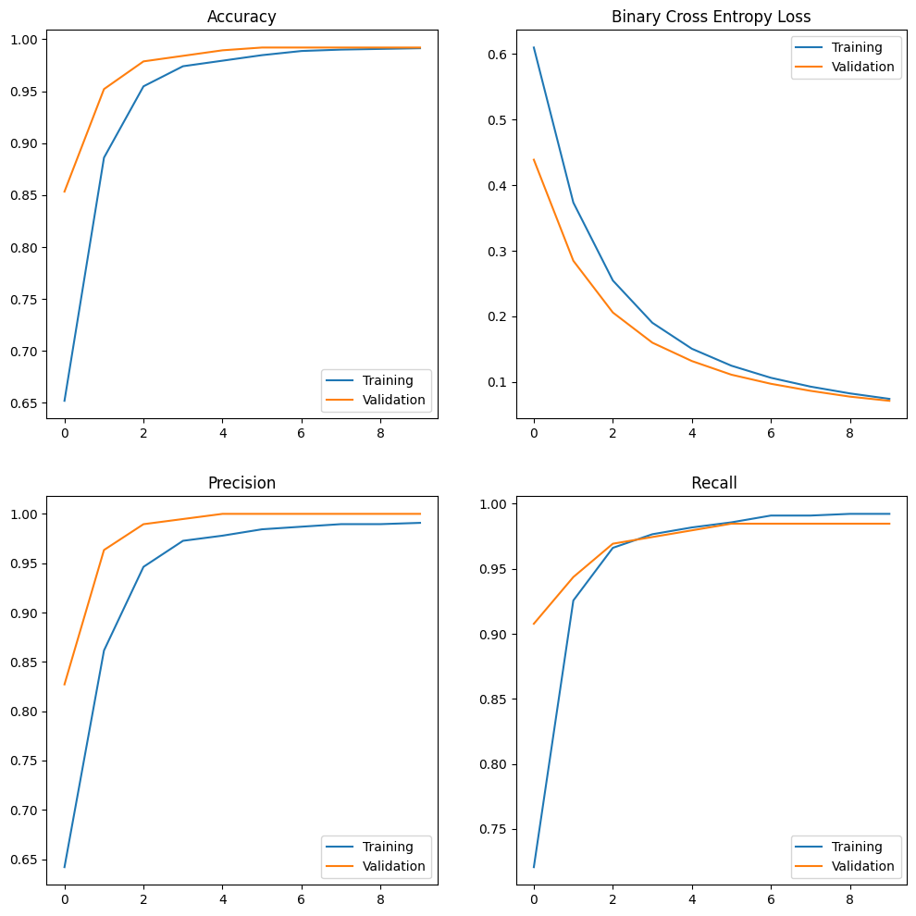

## 

## Neural Network Implementation & Refinement

The high scoring from the ResNet reference model confirmed a CNN would be the most effective approach to our problem. We began with a basic CNN architecture and through evaluation of performance, iterated results to improve our model.

### Basic CNN Model

A convolutional neural network, at its simplest, is defined by:

* A convolutional layer - to extract, transform and learn image features
* A pooling layer - to downsample and constrain the large number of parameters generated from the convolutional layer
* A flattening layer - to shape the data for dense layers
* A dense/fully connected layer - to converge features toward a prediction
* An output layer - for our problem, a sigmoid layer returning a classification

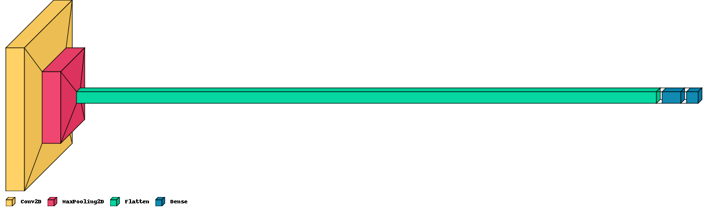

This was our first and simplest model, using 32 convolutional units. After training 50 epochs, we were able to see accuracy steadily increasing for the training and validation curves. However, we had a long way to go to increase the learning capacity of our model.

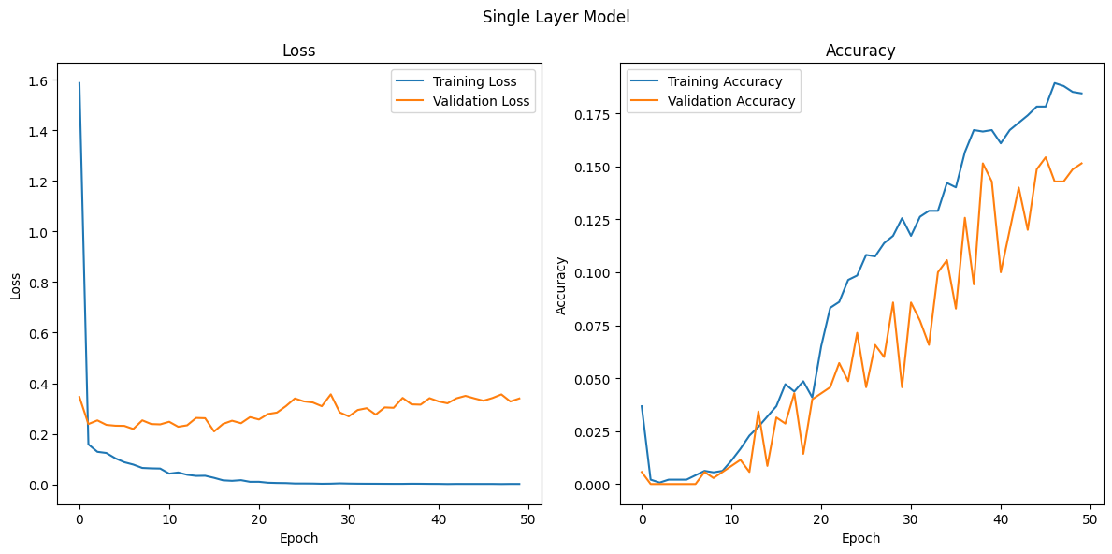

### Three Layer CNN

We added two more convolutional layers with 64 and 128 neurons to increase the depth of learning and the contextual information available to each neuron. This improved the accuracy of our model to about 40%, but still far underperformed our reference models. At the same time, loss had diminished to a negligible level over the epochs.

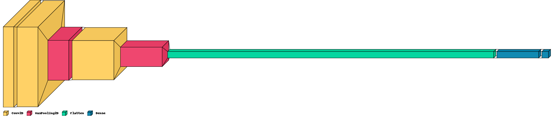

It was clear the model had to train more deeply, but we did not want to risk overfitting, which we began to see evidence of below..

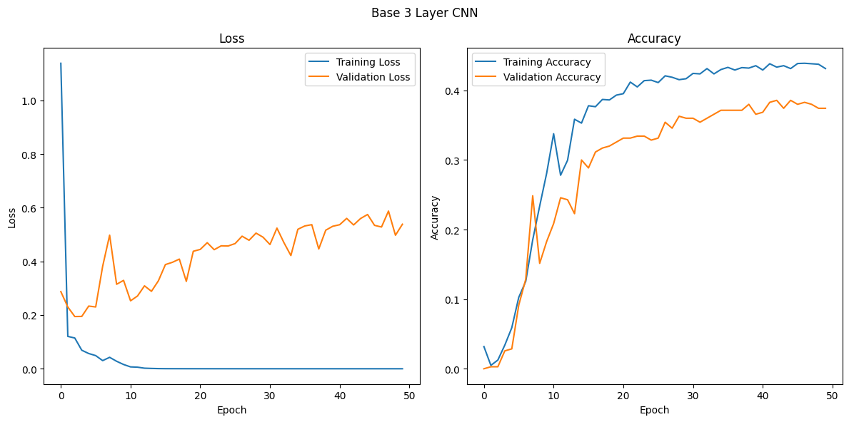

### Adding Neurons, Padding and Drop Out

We first reviewed the output shape of each level and identified a small amount of information loss at each layer due to filter/step size. We added a small amount of padding to preserve the details around the edges of each image for each convolutional layer.

We increased the complexity of the first convolutional layer from 32 to 64 units and doubled the units in each subsequent convolution to increase the ability to construct more features at each level. We also added dropout to the dense layer to prevent overfitting and keep the loss function on the training data from declining too quickly. The result was a model with 250 million trainable parameters, 16 times the size of our single layer model.

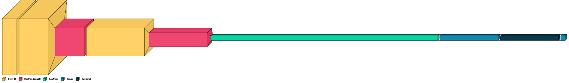

After training this model, the effects of the dropout were evident with more volatility in the accuracy curve, however it did not improve performance. The model peaked at about 40-45% accuracy as before, but then began to decline with more epochs. It was also unclear if starting the model with 64 units in the first layer added any learning ability to the model.

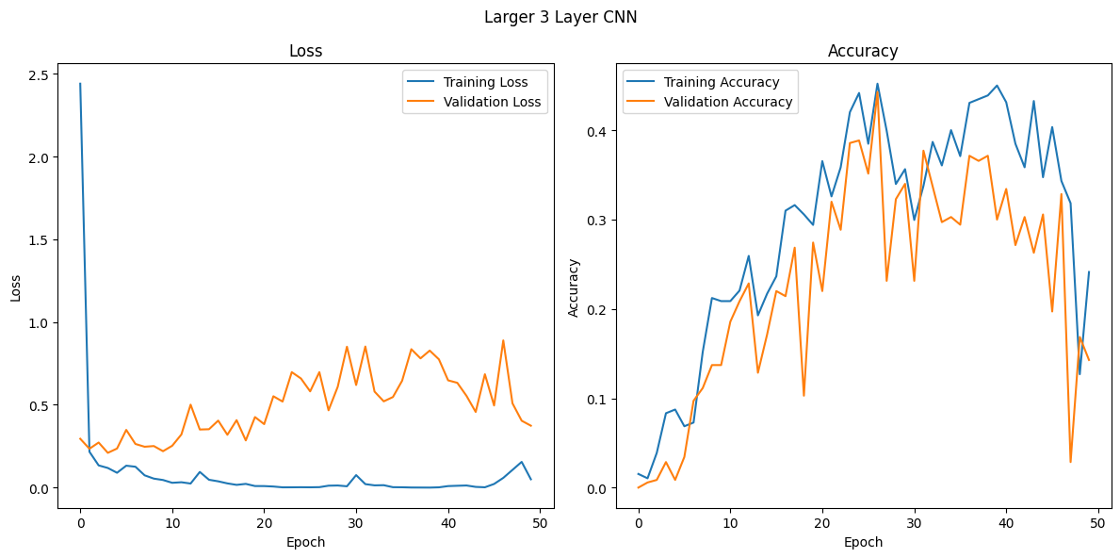

### Adding Convolutional Blocks

We removed the drop out and instead continued to increase the model’s depth and complexity. We added a fourth convolutional layer and grouped the convolutions into two blocks, each followed by a pooling layer for downsampling. We wanted to prevent the loss of potentially useful information during downsampling and thus continued to only use 2 pooling layers.

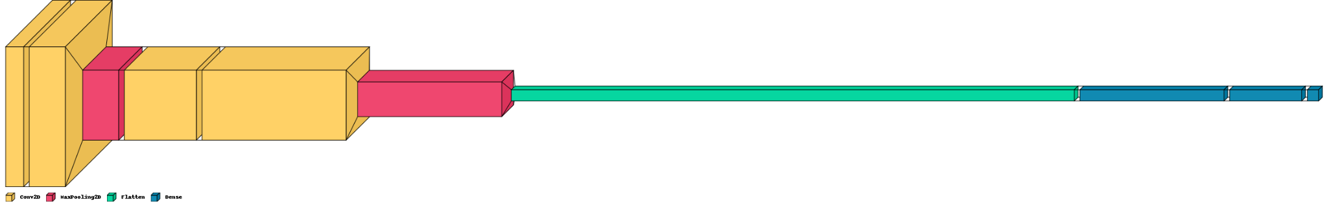

With these additions, the model grew to 252 million parameters, so we added a second fully connected layer to gradually condense the model’s information before the sigmoid output.

This more complex model improved the accuracy marginally, nearing 50% on the training data, while the validation data was nearing 45% and more closely related to the training accuracy. In spite of this improvement, the model performed no better than a coin flip. The accuracy plateaued at about epoch 20, where the loss on the training data reached almost zero. This was similar to the behavior we saw in the three layer CNN, prior to implementing dropout.

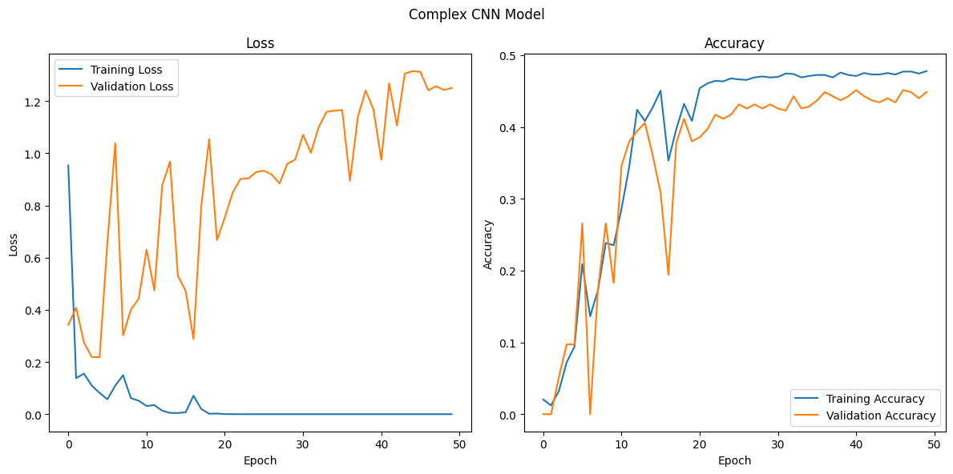

We added drop out in the dense layer and trained longer to 150 epochs. The model’s accuracy and loss fluctuated far more in this version than in the prior version without dropout. Though it allowed us to train longer, it did not improve the model’s accuracy. We faced a ceiling of about 50% on the training data and 40% on validation.

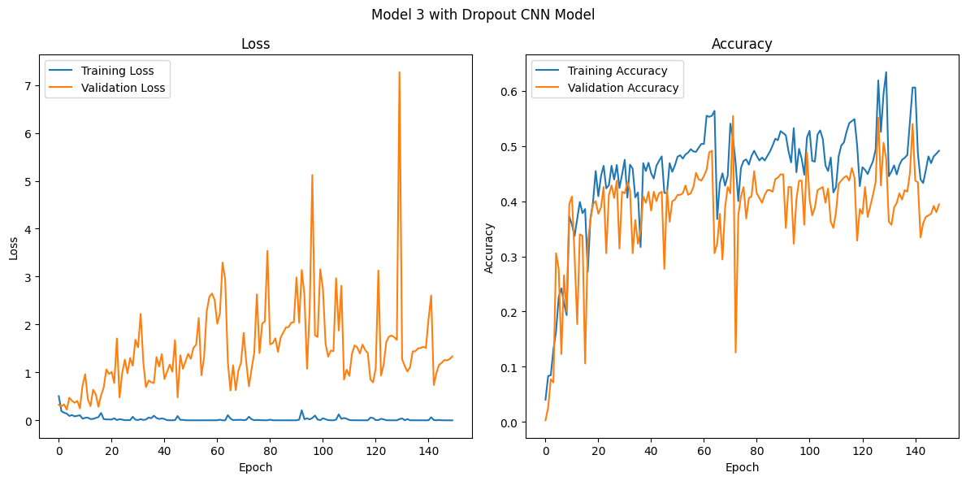

### Six Layer CNN

Next, we added a third pair of convolutions, each with 256 kernels, aiming to support the model’s ability to articulate more complex and broader features. We also removed the padding to prevent the number of parameters in the model from growing too large. We retained dropout on the dense layers to prevent overfitting during extended training.



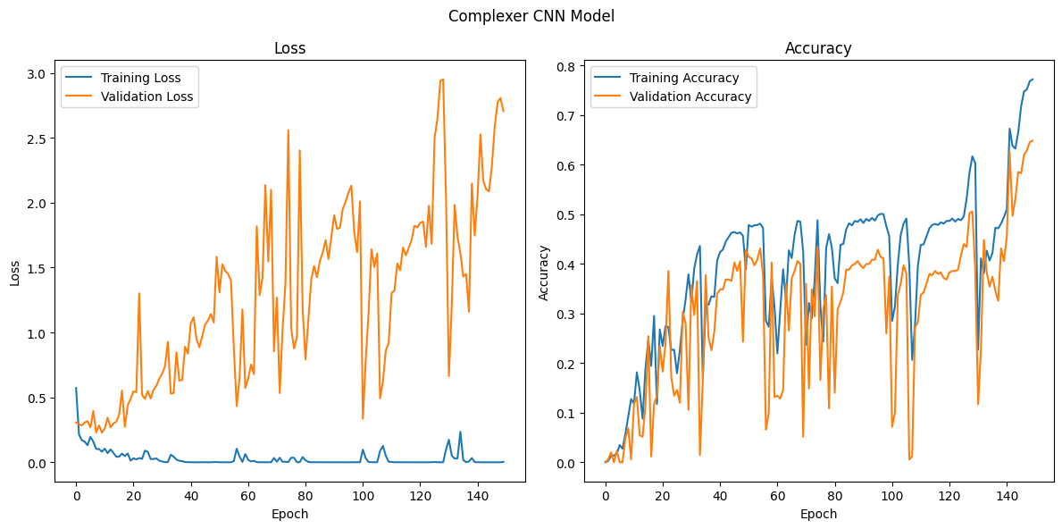

The model was able to get over 60% validation accuracy after 150 epochs, but the end result was still not very good. The accuracy fluctuated greatly during training, which suggested the possible existence of a vanishing gradient, which would inhibit our model’s learning abilities.

Finally having broken through the 50% ceiling, we found it interesting that once the model did so, it appeared to be able to increase accuracy more quickly. This is seen above in the final 10 epochs. Despite having hovered consistently around 50% on training, once the model broke past this point, it jumped significantly to nearly 80% in the matter of the last few epochs. This observation makes sense as once the model is able to get more correct than not, it has more positive feedback to make more informed back propagation and successfully improve itself more quickly.

While the model was still improving at the end of this training, we felt that if we could continue to improve the model to break this 50% barrier in a few epochs, then we may reach our goal without having to train the model even longer.

**Skip Level Connections**

Given the possible gradient loss, we took a cue from our Resnet reference model and added skip layers to preserve data across the last two convolutional blocks. This refinement did reduce dips in the accuracy curve but did not improve overall model performance with validation accuracy hovering at most around 40%, so we abandoned this approach.



### A Winning Model

**Increased Kernel Size**

To this point, we had increased the number of filters in each layer to allow the model to construct more features. In our final model structure, we increased the size of the kernels on the first two convolutional layers to enable the model to construct broader features to learn from. Increasing the size of kernels at the first level and then decreasing subsequent layers is a common technique used to gain more features in the model at the smallest granularity and allow the model to have more features to construct the broader image themes from at the deeper levels.

We increased the kernel size in the first convolutional layer from 3x3 to 7x7. The second layer was increased from 3x3 to 5x5.

Additionally, we increased the kernel size in one of the convolutional layers in each of the second and third convolutional pairs. However, unlike in the first pair where we started with larger kernels and then went smaller, in the second and third pairs we did the reverse. Increasing the size of the kernels as training went deeper allowed the model to construct the larger or more broad features in the images.

**Increased Neurons and Removed Dropout**

We also increased the number of neurons in the first dense layer to 1024. This provided the model with nearly double the number of parameters as we had in the prior model – giving us a total of 167 million parameters, roughly 10 times that of our single layer model. We removed the dropout from the dense layers, hoping to allow the model to overfit and prove the viability of the model. If successful, we could then revisit methods to address any overfitting.

**Optimizing the Optimizer**

Lastly, another change we made in this iteration was replacing the optimizer Adam with RMSProp. We chose this because of the continued observation of the training loss function to quickly approach zero while there remains more room to improve accuracy. Using RMSProp reduced the impact of momentum on the learning rate, and we believed it would allow the model to continue to improve for a longer period of epochs while also having the benefit of increasing the speed of training, by not having to compute the running average calculation for the momentum component of Adam optimization.

The addition of these larger features and reducing momentum significantly improved the model’s training with a validation accuracy of 79% after 50 epochs and a maximum of 83% during training.

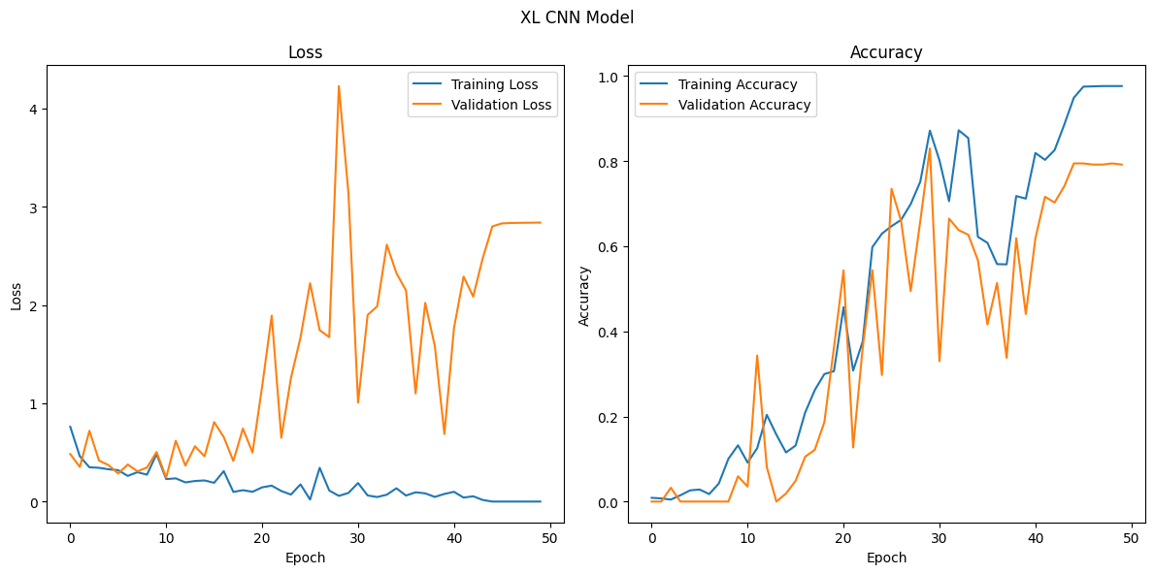

This model plateaued during training at epoch 44. There is nearly a 20% difference between the training and validation accuracy. This indicated to us that while this model was successful in drawing information from the data, it had become overfit. Confident in this final model, we experimented with a few methods of regularization to reduce the overfitting (L2 and dropout).

**Further Tuning**

**L2 Regularization**

Since we had previously experimented with dropout in prior iterations, we decided to first try L2 regularization in the dense layers. This ultimately proved unsuccessful generating a maximum of only 47% on the validation data. With this result, we removed the L2 regularization.

**Adam Optimizer**

Next, we set out to test a hypothesis regarding the Adam optimizer. In the prior iterations we had exclusively used the Adam optimizer, before switching to RMSProp in this model. We had observed the loss diminishing quickly during training, reaching near zero and preventing the model from learning further. However, in this model, RMSProp appeared to have been a significant factor in the model being successful and continuing to learn for a longer period of training.

*Hypothesis****:*** *The momentum term in the Adam optimizer is causing the learning rate to decrease too quickly, driving the loss down, and preventing the model from learning the necessary features to improve.*

Keeping all other model construction unchanged, we changed the optimizer back to Adam and ran the training. If using the Adam optimizer did not adversely affect the training of our model, we should expect to see the model perform similarly in terms of accuracy. However, the model was only able to reach a maximum of 17% on the validation data. This indicated to us that our hypothesis was correct and supported our decision to use RMSProp as the optimizer in our final model.

**Dropout**

Lastly, we returned to using dropout to prevent overfitting and increase generalizability of the model. We implemented a 30% dropout rate in the two dense layers and increased the number of epochs to 100, to allow the model ample time to learn and build alternative pathways through these dense layers.

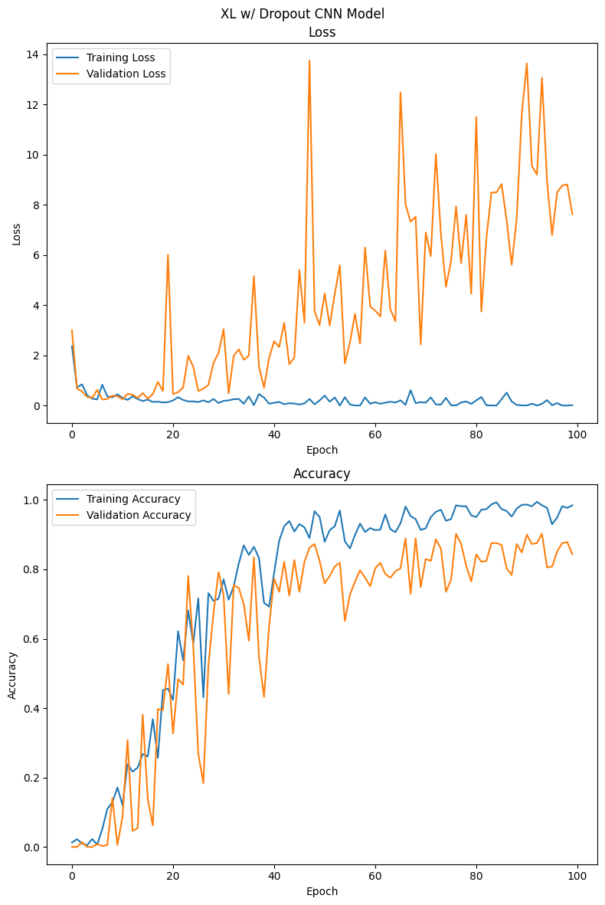

As expected, the accuracy fluctuated more while using the dropout. With the dropout, the difference in accuracy between the training and validation sets was less pronounced, indicating it helped to prevent overfitting.

Ultimately, adding drop out to the dense layers and allowing the model to train to 100 epochs gave us our winning model with a maximum of 90% validation accuracy during training.

**Model Diagram**

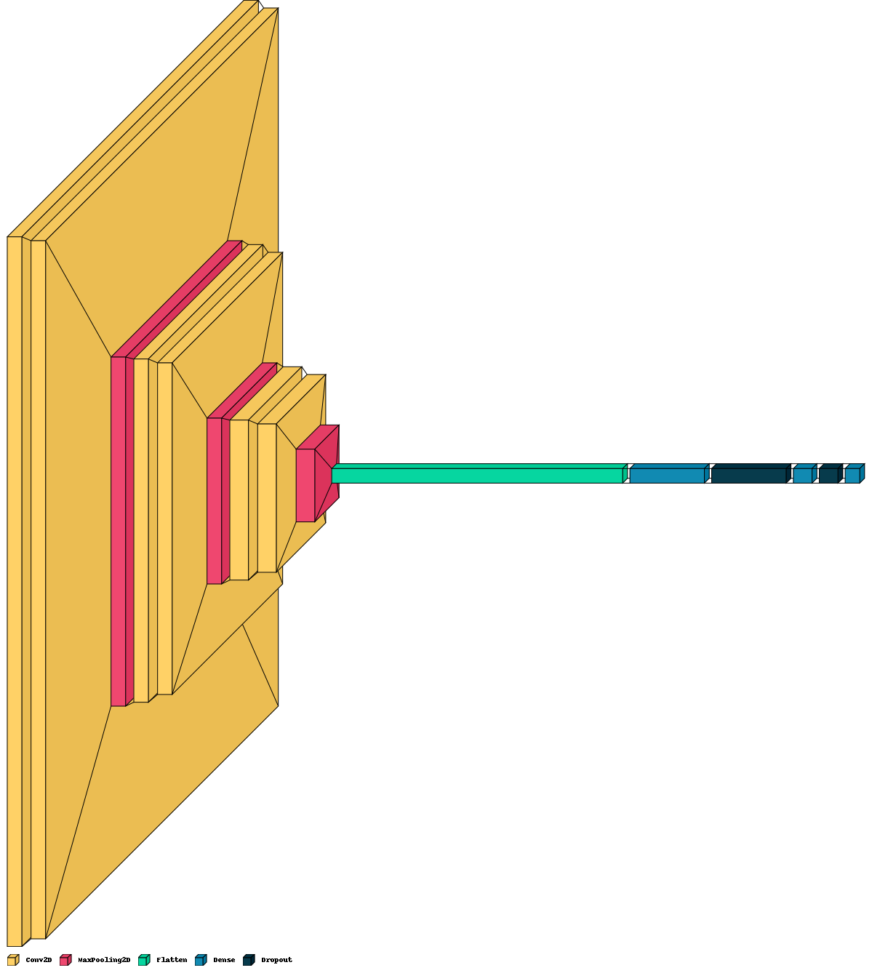

### Summary of Tuning

|  | **Key Model Features** | **No. of Parameters** | **Epochs** | **Max Validation Accuracy During Training** |
| --- | --- | --- | --- | --- |
| 1 | Single Layer CNN - 32 kernels/1 layer | 15.7 million | 50 | 0.15 |
| 2 | Three Layer CNN - 32/64/128 kernels | 49 million | 50 | 0.39 |
| 3 | Three Layer CNN - 64/128/256  padded + dropout | 250 million | 50 | 0.44 |
| 4 | Four Layer CNN - 32/64/128/256 +  Third dense layer | 252 million | 50 | 0.45 |
| 5 | Four Layer CNN - add drop out | 252 million | 150 | 0.55 |
| 6 | Six Layer CNN - 32/64/128/128/256/256 | 97 million | 150 | 0.65 |
| 7 | Six Layer CNN - add skip levels | 127 million | 50 | 0.40 |
| 8 | Six Layer CNN - increase filter size  Dense layer 1024 + RMS Prop optimizer | 167 million | 50 | 0.83 |
| 9 | Six Layer CNN - add L2 Regularization | 167 million | 100 | 0.47 |
| 10 | Six Layer CNN - Adam optimizer | 167 million | 100 | 0.17 |
| 11 | Six Layer CNN - RMS Prop + drop out | 167 million | 100 | 0.90 |

## 

## Conclusions

### Evaluation of the Final Model

We evaluated our final model using 68 unseen images reserved for testing.

The model accurately predicted 92.7% of the images with an AUC of 0.94, indicating the model had a strong ability to distinguish between the Fire and No Fire classes. Recalling that our XGBoost reference model performed with 77% accuracy and the ResNet model performed with 99% accuracy, this was a very high level of performance and with a fairly simple design for a CNN image classifier.

### 

Our success in fire image classification confirmed for us that given a larger sample size of Waldo images, leading to balanced classes in our initial problem, we would be able to use a CNN to help us find Waldo.

### Error Investigation and Next Steps

The model misclassified five test images - four of which were false positives. Each of these were images with high concentrations of red in the lower part of the image.

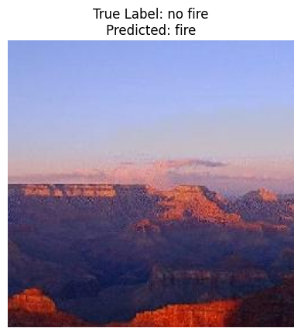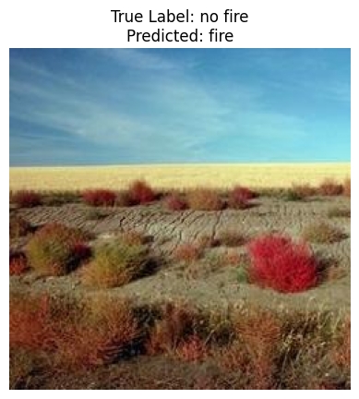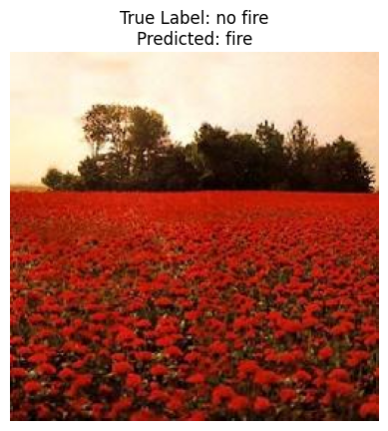

Sample false positives

The single false negative image had the opposite quality - it was a photo of a fire on top of a distant hill, a dense cluster of amber toward the top part of the image. Even by visual inspection, the photo nearly resembles a sunset.

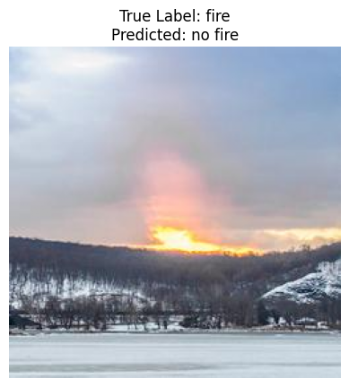

These findings are consistent with what we noticed during data exploration – densities of red in the lower part of the image are a prevalent quality of the Fire class, and the model apparently prioritized this feature.

To remedy these errors and enhance the model in the future, we would supplement the training data with additional images of red and orange plants and other landscape features, labeled as No Fire. These would be provided to the model with the aim of helping it learn with greater nuance between colorful red landscapes and actual fires. Another option would be to perform image augmentation on both the fire and not fire images. As noted in the data exploration, fire images tended to have more red toward the bottom half of the image, while not fire images had more green and blue at the top of the image. By rotating the images, we might break the model’s reliance upon these distinctions of sky and horizon and of fire rising through the image. This may make the model less reliant upon the location of color in the images and make it more robust to different orientations as well.

# 

# References

**Datasets**

GitHub: Where’s Waldo Dataset - Valentino Constantinou. <https://github.com/vc1492a/Hey-Waldo>

Kaggle: Wildfire Detection Image Data - Baris Dincer.

<https://www.kaggle.com/datasets/brsdincer/wildfire-detection-image-data/>

**Reference Models**

Keras: ResNet50 and ResNet50v2 Applications. <https://keras.io/api/applications/resnet/>

**Research**

ArXiv: *Deep Residual Learning for Image Recognition.* Dec 2015. [Kaiming He](https://arxiv.org/search/cs?searchtype=author&query=He,+K), [Xiangyu Zhang](https://arxiv.org/search/cs?searchtype=author&query=Zhang,+X), [Shaoqing Ren](https://arxiv.org/search/cs?searchtype=author&query=Ren,+S), [Jian Sun](https://arxiv.org/search/cs?searchtype=author&query=Sun,+J). <https://arxiv.org/abs/1512.03385v1>

Machine Learning Mastery: *A Gentle Introduction to Object Recognition With Deep Learning.* Jan 2021. Jason Brownlee, PhD. <https://machinelearningmastery.com/object-recognition-with-deep-learning/>

Saturn Cloud: *A Guide to Convolutional Neural Networks - the ELI5 Way*. Dec 15, 2018. Sumit Saha. <https://saturncloud.io/blog/a-comprehensive-guide-to-convolutional-neural-networks-the-eli5-way/>

TensorFlow: *Classification on Imbalanced Data.* [https://www.tensorflow.org/tutorials/structured_data/imbalanced_data](https://www.tensorflow.org/tutorials/structured_data/imbalanced_data#check_training_history)/

*Hands-On Machine Learning with SciKit-Learn, Keras & TensorFlow*. 3rd Ed. Aurelien Geron.

*Here’s Waldo: Computing the optimal search strategy for finding Waldo*. Feb 3, 2015. Dr. Randal S. Olson. <https://randalolson.com/2015/02/03/heres-waldo-computing-the-optimal-search-strategy-for-finding-waldo/>

Medium: *Image classification using CNN.* Feb 24, 2024. Sarka Pribylova. <https://medium.com/@sarka.pribylova/image-classification-using-cnn-0fad8367acfd>

Ruder.io: *An overview of gradient descent optimization algorithms.* Jan 19, 2016. Sebastian Ruder. <https://www.ruder.io/optimizing-gradient-descent/#rmsprop>

YouTube: *Build a Deep CNN Image Classifier with ANY Images.* Apr 25, 2022. Nicholas Renotte. <https://www.youtube.com/watch?v=jztwpsIzEGc&t=3528s>

YouTube: *C4W3L01 Object Localization.* Nov 7,2017. DeepLearningAI. <https://www.youtube.com/watch?v=GSwYGkTfOKk>

YouTube: *C4W3L02 Landmark Detection.* Nov 7, 2017. DeepLearningAI. <https://www.youtube.com/watch?v=rRB9iymNy1w>

YouTube: *C4W3L03 Object Detection.* Nov 7,2017. DeepLearningAI. <https://www.youtube.com/watch?v=5e5pjeojznk>

YouTube: *C4W3L09 YOLO Algorithm.* Nov 7, 2017. DeepLearningAI. <https://www.youtube.com/watch?v=9s_FpMpdYW8>